Document title: Integration of selenium and cucumber with Jenkins_1.0
Version: 1.0
Classification: Confidential
Date of Issue: 11.07.2018
Produced By: Deepak Kumar, Ranjit Singh

Prerequisite:
- User is able to run cucumber runner java file using maven command line.
- Jenkins is installed successfully.
- Jenkins Plugins required
  - Cucumber Reports
  - Unleash Maven

- Login to Jenkins using below link.
http://localhost:8080/
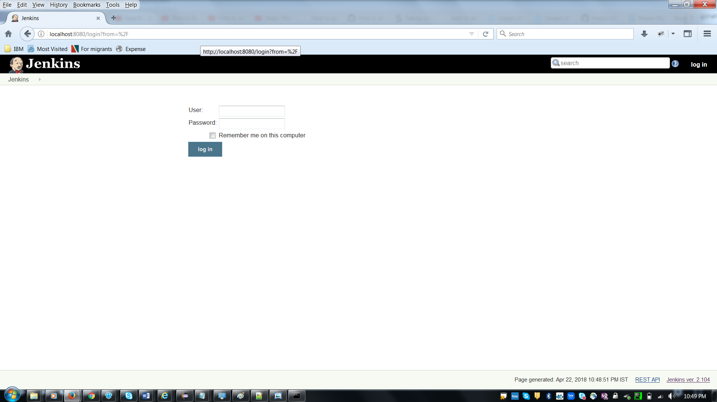

- Click on new Item.
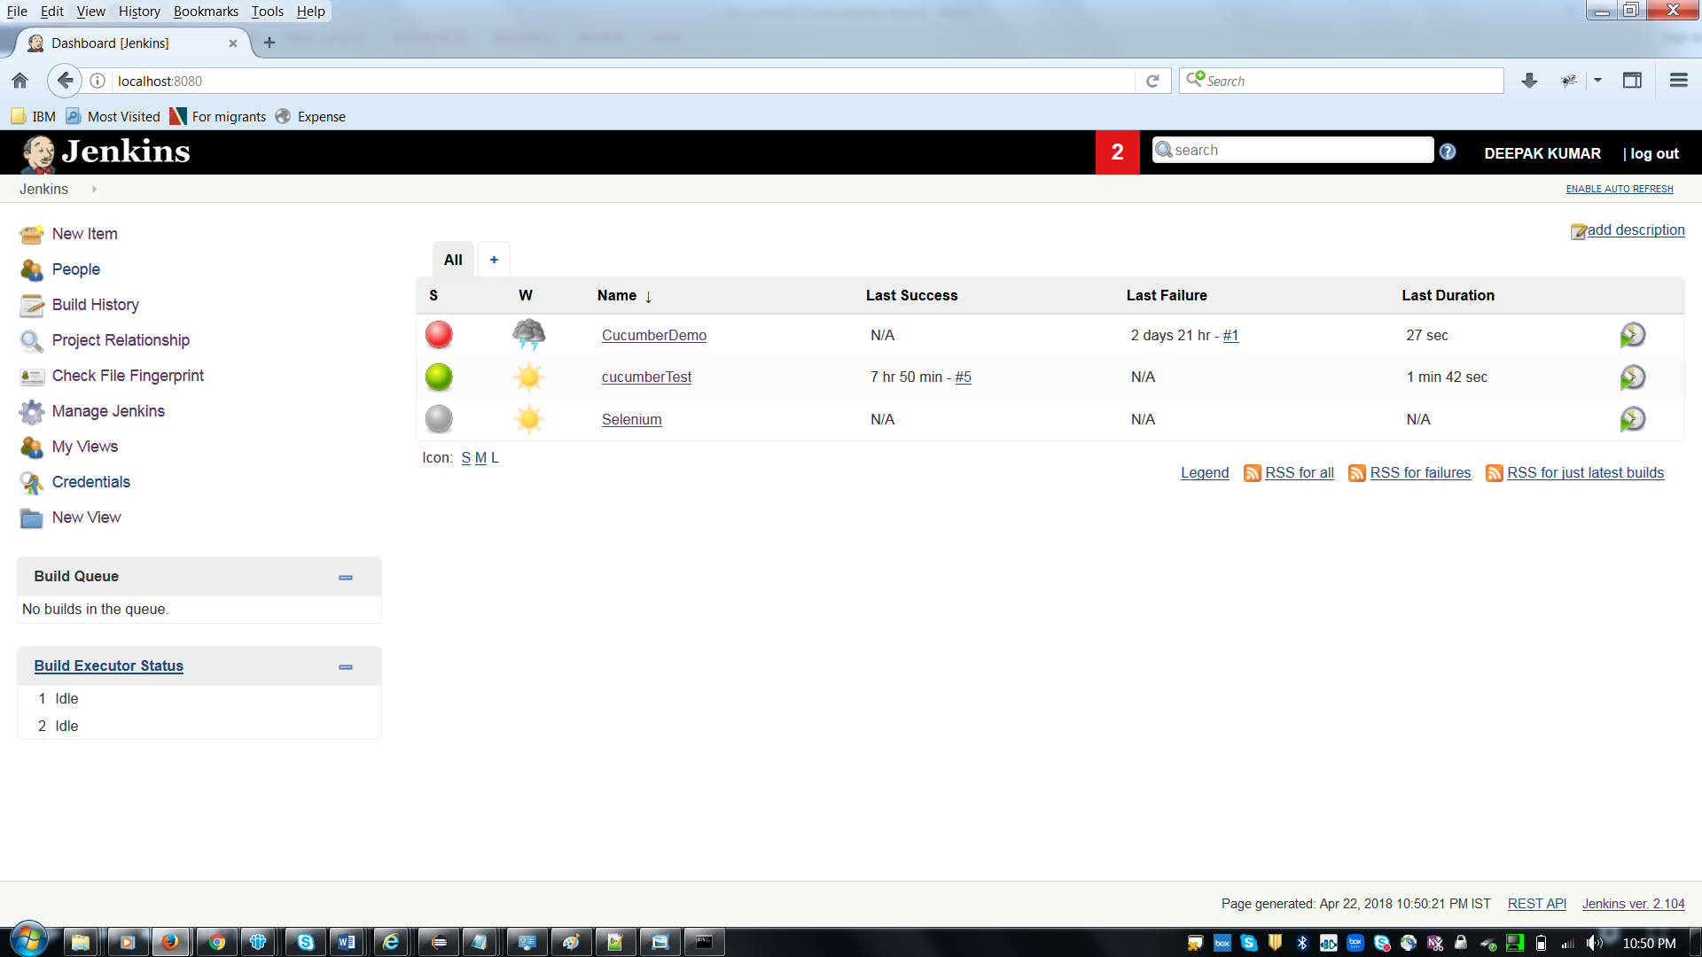

- Enter the item name and select the Maven project then click on OK button.

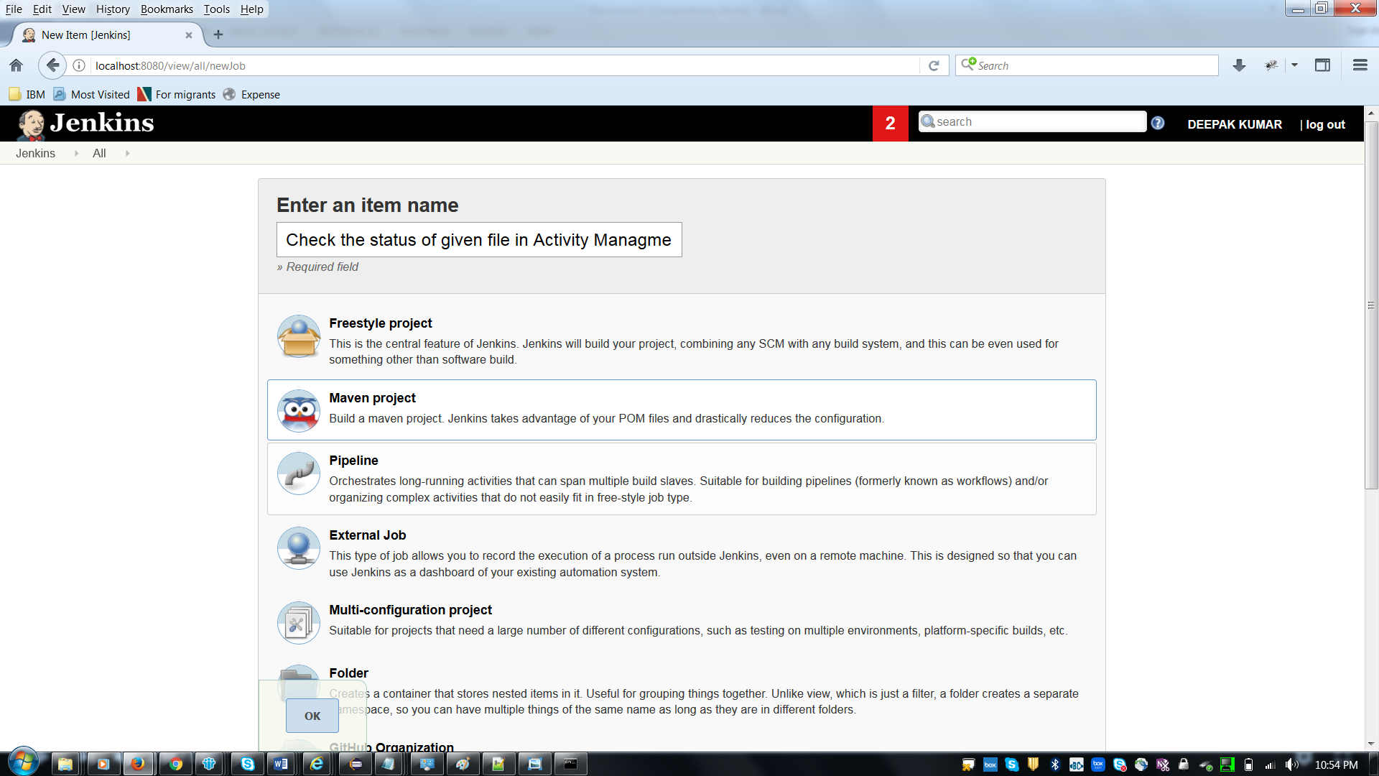

- Click on Build tab.
Enter Root POM as “Path of POM File”
Example: C:\WS_SGC\SGC_FlightManagement\pom.xml

Enter Goals and options as clean test

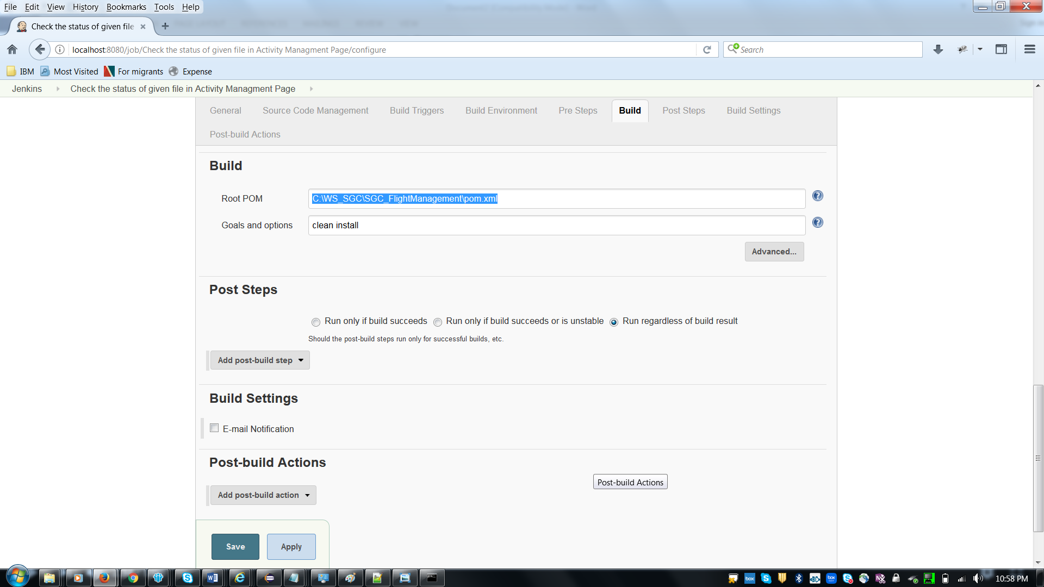

- Click on Post-build Actions
Add post build action as Cucumber Reports

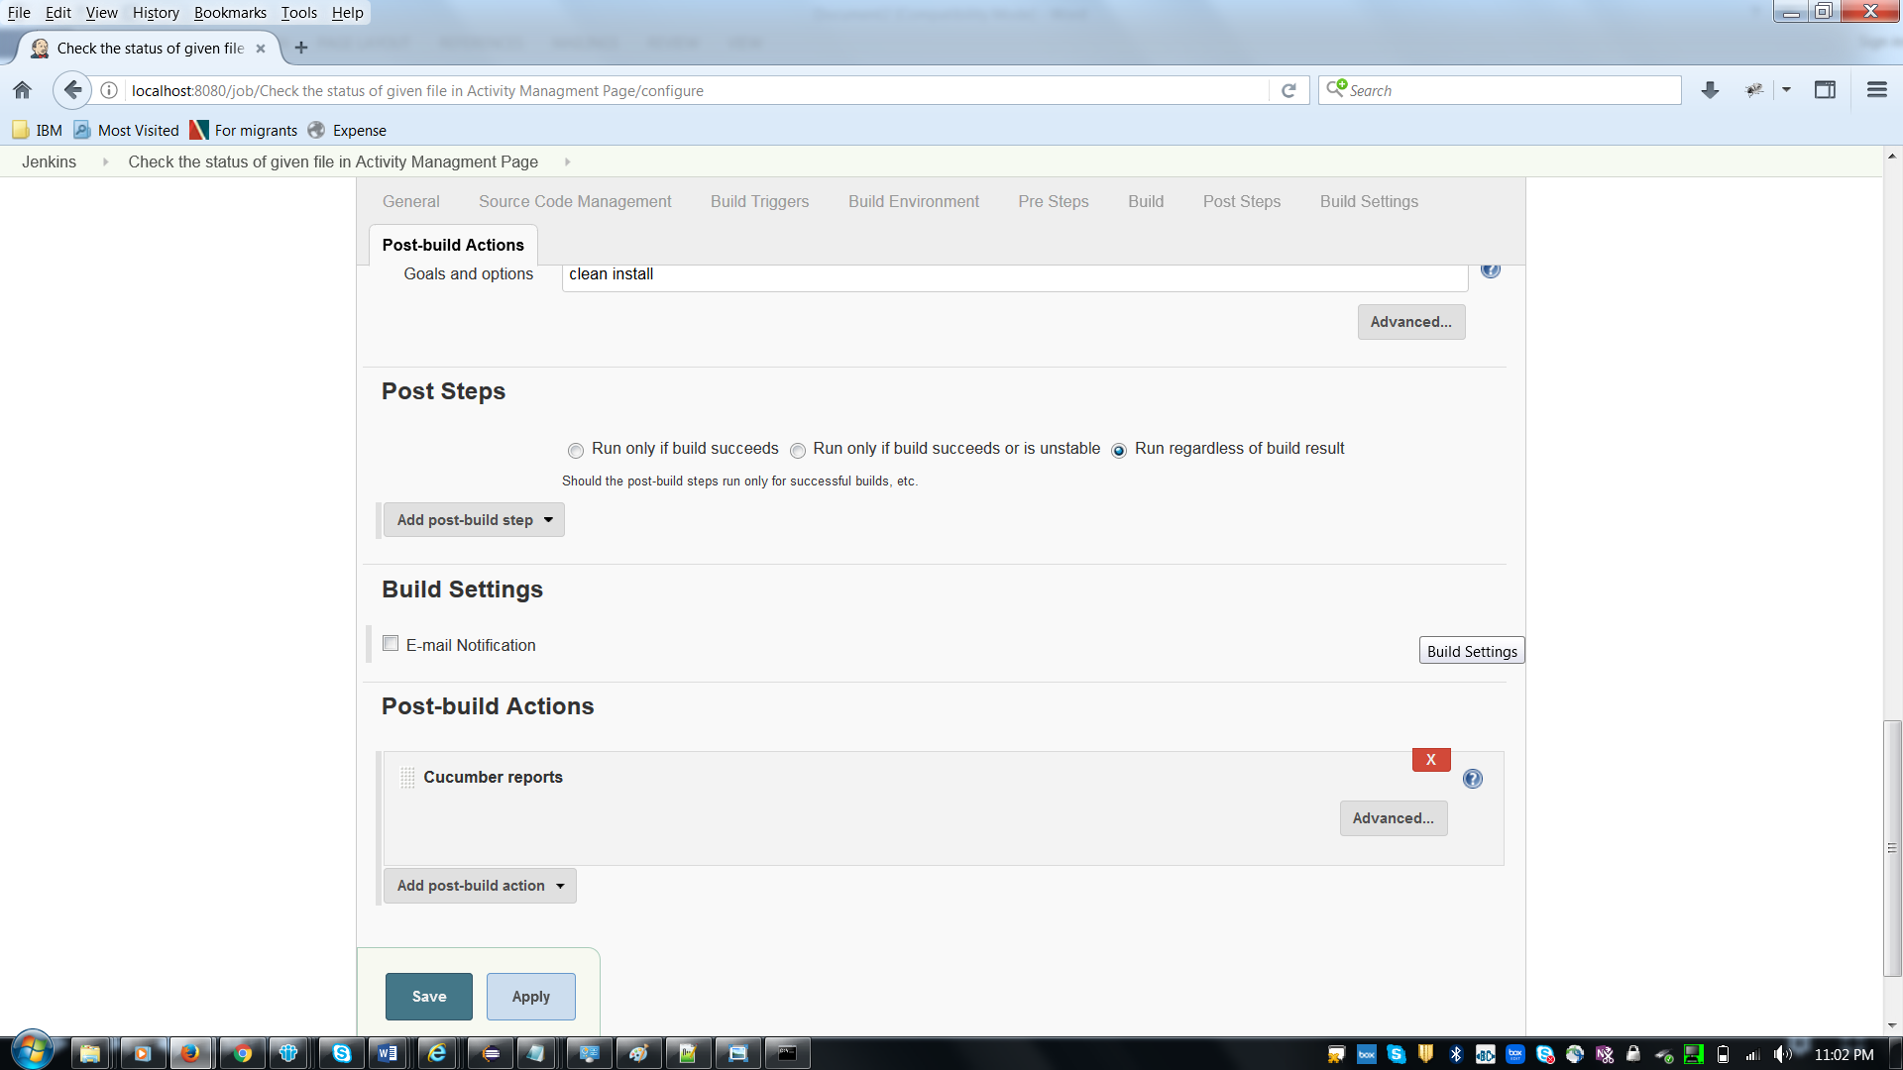

- Click on “Advanced” button under Post build Actions.
Enter Jason report path.
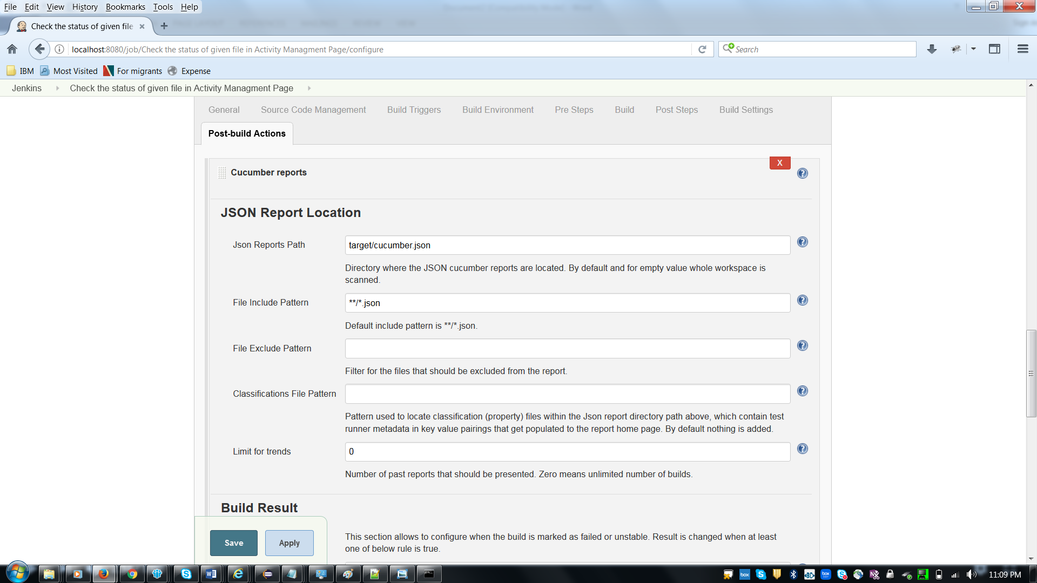
- Click on Apply and then save.
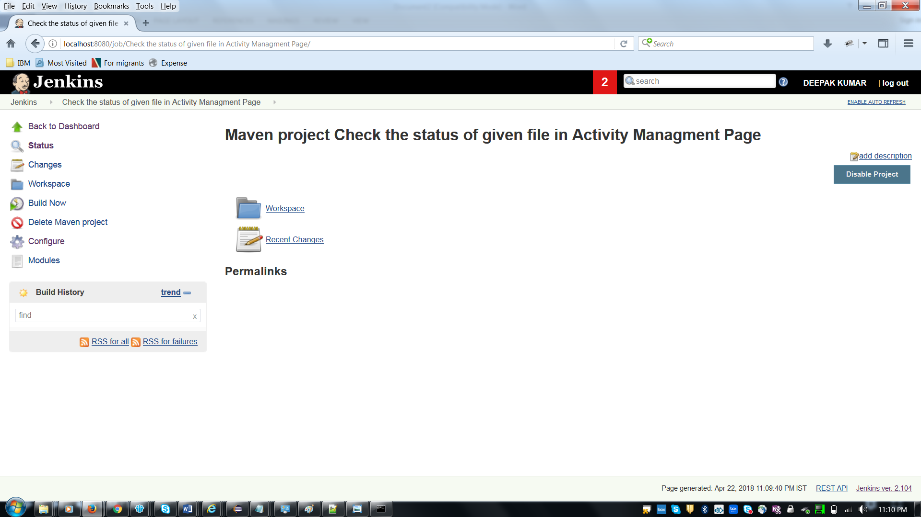
- Now click on “Build Now.”

